Completed Exemplar
To review the exemplar for this course item, click the link below and select “Use Template.”
Link to exemplar: Metrics for January
Assessment of Exemplar
Compare the exemplar to your completed document. Review your work using each of the sections in the exemplar. What did you do well? Where can you improve? Use your answers to these questions to guide you as you continue to progress through the course.
Note: If the current year isn’t 2023, your results will look different.
Acquisition metrics
If you browsed the user acquisition metrics independently, hopefully you didn’t miss the First user source option where Google Analytics breaks down the source of new users.
Below are the results for Google, Bing, YouTube, and Baidu from January 1, 2023 to January 31, 2023.
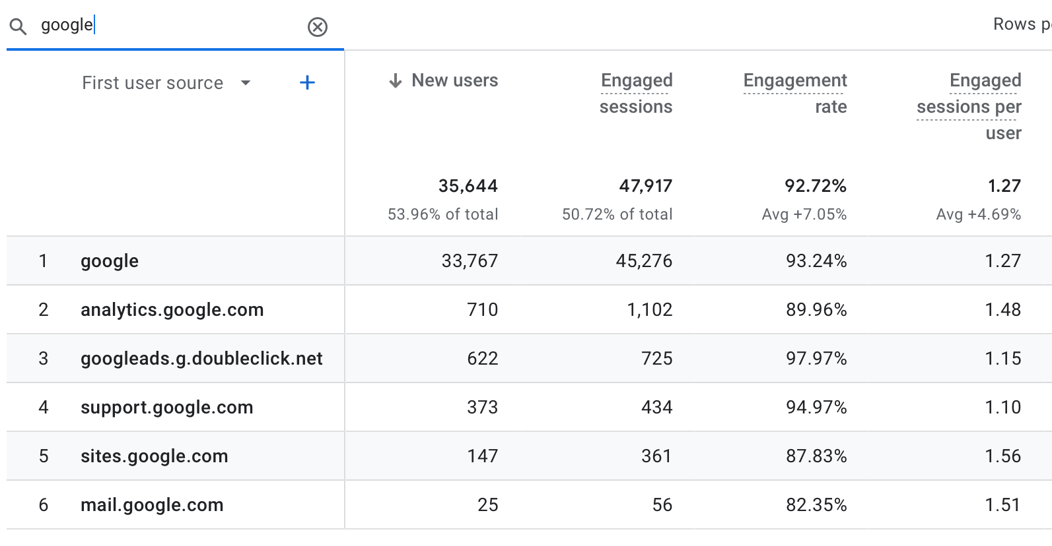
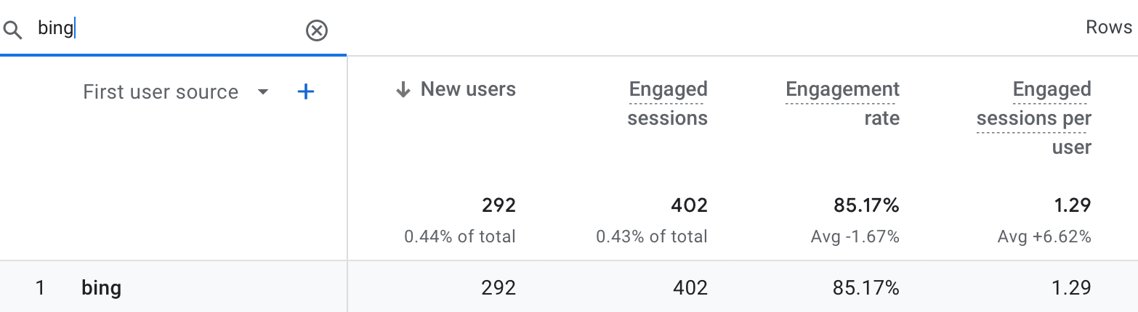
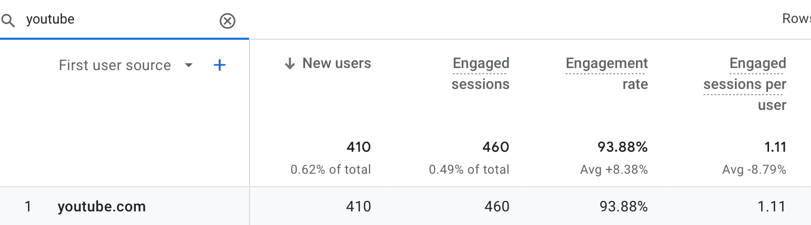
Below are the results for Baidu from January 1, 2023 to January 31, 2023. Notice the new mobile users counted.
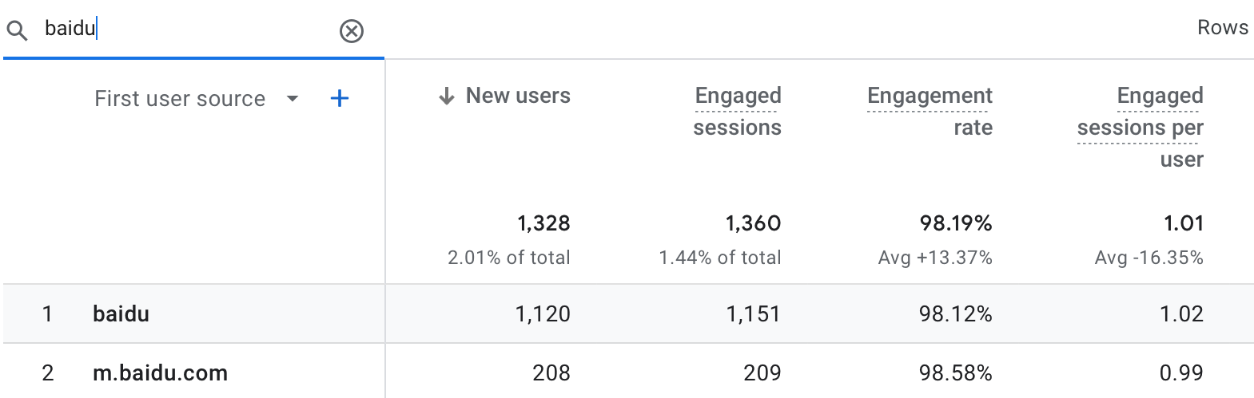
Engagement metrics
If you browsed the engagement metrics independently, hopefully you didn’t miss the importance of the metrics for events. You calculated the number of users with cart abandonment using the metrics for the begin_checkout and purchase events. You also calculated the sales conversion rate using the metrics for session_start and purchase events. These metrics are important to monitor for future promotions or remarketing efforts. Imagine increasing sales by re-engaging these users!
Below are the event metrics from January 1, 2023 to January 31, 2023.
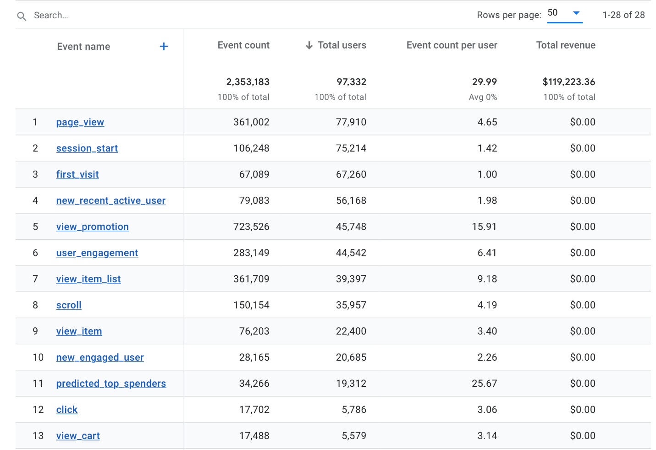
Monetization metrics
If you browsed the monetization metrics independently, you might have noticed how useful the Overview page is. You were able to find the number of first-time purchasers and the top-selling items from this page. These metrics are important to monitor for growth. Imagine increasing the number of first-time purchasers through a promotion on the most popular items!
Below is the monetization overview for January 1, 2023 to January 31, 2023.
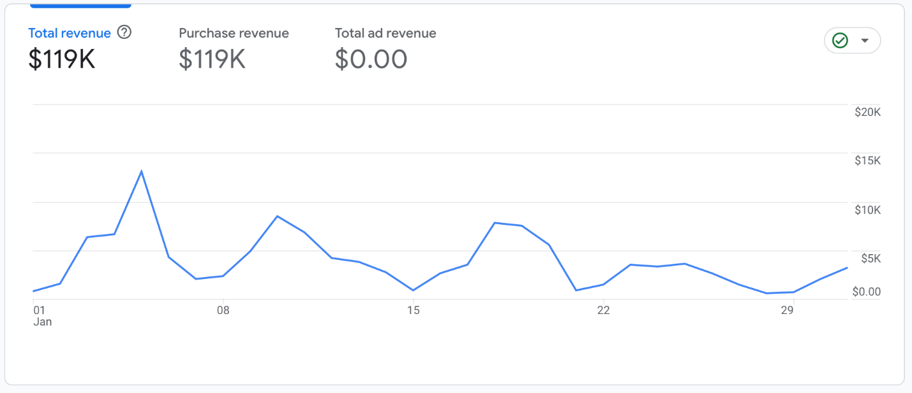
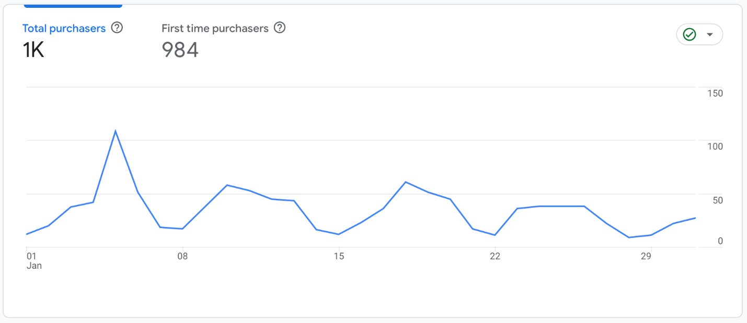
Below are the top-selling items from January 1, 2023 to January 31, 2023, as shown on the monetization overview page.
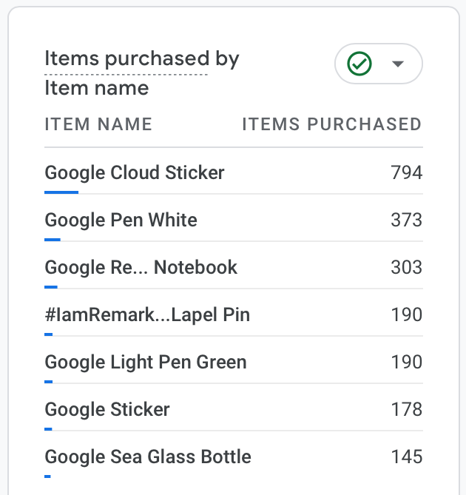
Completed

Acquisition metrics
Your manager asked you to find the number and percentage of new users who arrive at the Google Merchandise Store after using one of four search engines. Find the data in Google Analytics and record the metrics in the table below.

Search engine | Total new users  66,061 | Number of new users  (each search engine) | Percent of new users  Number of new users /  Total new users x 100
Google | — | 33,767 | 51.1%
Bing | — | 292 | 0.44%
YouTube | — | 410 | 0.62%
Baidu | — | 1,120 | 1.7%

Did you observe anything interesting with the metrics from YouTube or Baidu?

Bing had the highest average engagement time among search engines at 1 minute and 54 seconds. Baidu had the highest engagement rate at 98.12%.

Google Analytics collects the metrics for Baidu searches from mobile users. There were 208 new users from the mobile source, m.baidu.com.

Engagement metrics
Your manager asked you to find the total users for the following events:
- session_start
- begin_checkout
- remove_from_cart
- purchase

Additionally, your manager asked you to calculate the number of users with cart abandonment and the percentage of users with cart reduction.

Find the data in Google Analytics and record the metrics in the table below. Then, perform the required calculations and record your results.

Events | Total users
session_start | 75,214
begin_checkout | 1,652
remove_from_cart | 1,123
purchase | 1,007

Number of users with cart abandonment: 1,652 - 1,007 = 645

Sales conversion rate: (1,007 / 75,214) x 100 = 1.34%

Monetization metrics
Your manager asked you to find the total revenue, the number of first-time buyers, and the top three best-selling items. Find the data in Google Analytics and record the metrics in the table below.

Total revenue | Number of first-time purchasers | #1 item sold | #2 item sold | #3 item sold
$119,000 | 984 | Google Cloud sticker | Google Pen White | Google Recycled Grey Notebook

